


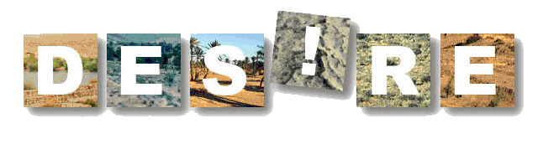

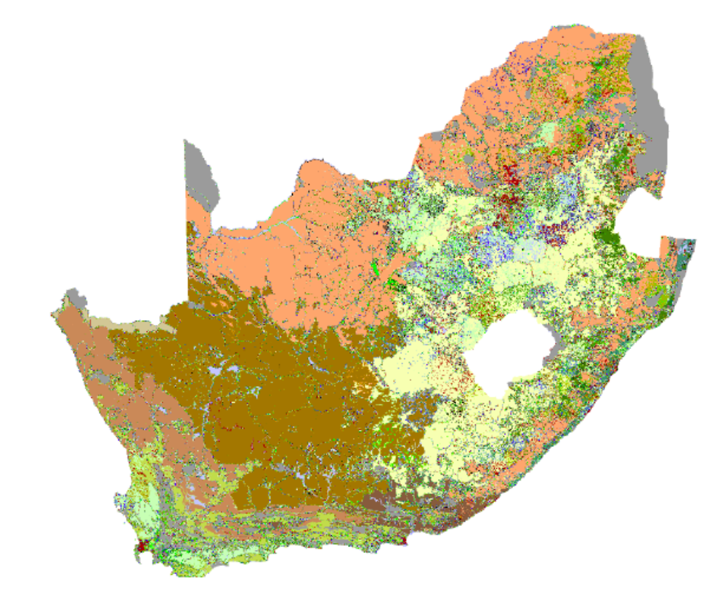

Questionnaire for

Mapping Land Degradation
and Sustainable Land Management.
(QM)

Version 1.0
Title: A Questionnaire for Mapping Land Degradation and Sustainable Land Management
Editors: Hanspeter Liniger, Godert van Lynden, Freddy Nachtergaele, Gudrun Schwilch
Copyright © 2008: CDE/WOCAT, FAO/LADA, ISRIC

Contact: WOCAT Secretariat:
CDE, Hallerstrasse 10, 3012 Bern, Switzerland,
Tel +41 31 631 88 22, Fax +41 31 631 85 44,
E-mail: wocat@cde.unibe.ch; hanspeter.liniger@cde.unibe.ch
http://www.wocat.net

LADA Secretariat
FAO, Food and Agriculture Organization of the United Nations, Viale delle Terme di Caracalla Viale delle Terme di Caracalla, 00100 Rome, Italy,
Tel +39 06 57054888, Fax +39 06 57056275,
E-mail: freddy.nachtergaele@fao.org
http://www.fao.org/nr/lada

ISRIC- World Soil Information
PO Box 353, 6700 Wageningen, Netherlands,
Tel +31 317 47 17 35, Fax +31 317 47 17 00,
E-mail: godert.vanlynden@wur.nl
http://www.isric.org
Acknowledgements
This “questionnaire” has been developed in a joint effort between the WOCAT, LADA, and DESIRE projects. The editors would like to acknowledge the numerous persons that have contributed to the development of this questionnaire. Special thanks goes to the donor agencies: Swiss Agency for Development and Cooperation (SDC), FAO, UNEP, UNDP and GEF.
Introduction
In spite of some progress made toward the Millennium Development Goals, hunger, poverty and food insecurity persist, while the key ecosystems that underpin and service the natural resource base continue to be depleted and degraded. These development challenges and the related pressure on the natural resource base are now recognised at a global level, and as a global issue. While driven primarily by population and economic growth, the pressures are exacerbated by a rapidly changing environmental context that includes, inter alia, land degradation, climate change, loss of biodiversity, water scarcity, liberalised trade regimes and demands for bio-energy production. These factors, furthermore, are linked and often self-reinforcing.

Sustainable management of the natural resource base is one of a very few, truly fundamental issues that the international community will be obliged to address effectively over the next two decades. The last twenty years have seen an emphasis on global and national economic management; the next twenty will need to address environmental management effectively.
This needs to follow a globally structured approach, based on adequate, reliable, up-to-date data and knowledge, and governed by appropriate international strategies and agreements. One key product sorely lacking to reach this goal is an overview of where land degradation takes place at what intensity and how land users are addressing this problem through sustainable land management. In order to fill this knowledge gap, three projects have come together to establish the current status, while mapping out a route forward.

The Land Degradation Assessment in Drylands (LADA) project aims at establishing and implementing a comprehensive methodology for the assessment and mapping of land degradation. The LADA assessment is carried out at three spatial scales (local, national and global), and considers land degradation status, drivers and impacts. Ultimately, LADA will provide a better understanding of the degradation phenomena, and will give indications for appropriate responses at all levels of scale.

The World Overview of Conservation Approaches and Technologies (WOCAT) has as mission to support innovation and decision making processes in Sustainable Land Management (SLM). The main objective of SLM is to promote long-lasting human coexistence with nature so that the provisioning, regulating, cultural and supporting services of ecosystems are ensured for future generations. Sustainable Land Management is defined as the use of land resources, including soils, water, animals and plants, for the production of goods to meet changing human needs, while simultaneously ensuring the long-term productive potential of these resources and the maintenance of their environmental functions. Furthermore SLM is an essential prerequisite for sustainable development

The DESIRE project aims to establish promising alternative land use and management conservation
strategies based on a close participation of scientists with stakeholder groups in the degradation and desertification hotspots around the world. This integrative participatory approach ensures both the acceptability and feasibility of conservation techniques, and a sound scientific basis for the effectiveness at various scales.

The three projects’ aims and missions are complementary, and in order to enhance their synergy this manual was prepared to streamline methods to map and document land degradation and land improvement at a national scale in a unique, yet common, way.
Practical Notes
- The ultimate goal of this exercise is to obtain a picture of the distribution and characteristics of land degradation and conservation / SLM activities for a district, a province, a country, a region, or ultimately world-wide. The final output will be maps of land degradation status, causes and impacts, and conversely the conservation status and impacts for major land use systems in the area.
- It is important to note that units to be evaluated will inevitably be large in absolute extent. This requires considerable analytical skill amongst the evaluators. The risk to be avoided is that an example of a particular gully or a particular conservation technology applied by a few farmers will be given undue attention, and its importance correspondingly overestimated.
- It is necessary to document and map not only so-called "successful" examples, but also those that may be considered – at least partially – failures. The reasons behind failure are equally important for the analysis. The map will display information on the dominant land degradation and conservation technologies for each important Land Use System in each country.
- It is important to evaluate the current situation, taking into account an historical perspective of the last ten years. Information should not reflect the expected, recommended, or modelled situation.
- It is recommended that the questionnaire be filled in by a team of land degradation and conservation specialists in consultation with land users with different backgrounds and experiences. These stakeholders must be familiar with degradation and conservation/SLM as well as the land use practices on cropland, grazing land, in forests, and on other land within the region or country being mapped.
- Use should be made of existing documents (maps, GIS layers, high resolution satellite images, etc.) and advice from other specialists and land users as much as possible in order to improve the quality and reliability of the data. This questionnaire should be used as an evaluation tool for land degradation and the conservation activities undertaken in a country or region. It is important to remember that the quality of the results entirely depends on the quality of the answers. In some places the information will be simple to obtain; but in others there may be no hard data available. In this latter case, we ask you to provide a best estimate, based on your professional judgement
- A separate matrix table must be filled for each mapping unit. Please make as many copies of the table as necessary before you start filling in the information.
- Filling all the information for each mapping unit using the matrix table and transferring the data to the database is one way of compiling the information and producing maps as a result.. However, as it may happen the information is not readily available for all mapping units. The interactive viewer provided with the mapping database helps fill information directly into the mapping units. In an interactive and participatory process involving several experts/knowledgeable resource persons the state of degradation and conservation can be assessed, corrections can be made based on their judgements and the results can be viewed immediately. This process helps to compare neighbouring units and adjust the “values” according to the best knowledge and judgement. It might also highlight for which areas a field survey is needed, if information is not available or there is disagreement between the resource persons.

- The lists with selectable items aim to be as comprehensive as possible, but if a specific item is not mentioned it can be catered for by adding it in comments within the database. As the manual covers national, sub-national and local assessments and mapping, it may be advisable not to use all the details possible but to focus on the major categories.
- If you wish to describe a SLM Technology or a SLM Approach used for the implementation of the technology more in detail, please download separate questionnaires on SLM Technologies and/or Approaches from the Internet (www.wocat.net). If you wish to get more information on how to evaluate land degradation at local level consult the LADA links to local assessment.
- Note that the questionnaire is a working document and users are welcome to amend it during their assessments to fit their specific needs. Feedback and improvements are highly appreciated and should be sent to the addresses below.
- Please enter the information in the online database, see or send the completed questionnaire plus any additional materials back to the respective project / programme coordinators; for WOCAT: wocat@giub.unibe.ch; for LADA: freddy.nachtergaele@fao.org; for DESIRE: WB1 coordinator godert.vanlynden@wur.nl.

Index

1 | USER’S GUIDE
 | Background | E 1
 | Base Map | E 1
 | Steps of data collection | E 2
 | Step 1: Contributing specialists | E 2
 | Step 2: Land Use System | E 3
 | Explanations to step 2 | E 3
 | Step 3: Land degradation per land use system | E 5
 | Explanations to step 3 | E 5
 | Step 4: Land conservation per land use system | E 14
 | Explanations to step 4 | E 14
 | Step 5: Expert Recommendation | E 22
2 | QUESTIONNAIRE
 | Contributing specialists | Q 1
 | Matrix table (part 1) | Q 2
 | Matrix table (part 2) | Q 3
 | ANNEXES
 | I: Categorisation system of land use systems, degradation and conservation, indicators
 | II: Additional Information
 | III: DPSIR framework

USER’S GUIDE

Background
The WOCAT-LADA-DESIRE mapping tool is based on the original WOCAT mapping questionnaire (WOCAT, 2007). It has been expanded to pay more attention to issues like biological and water degradation and places more emphasis on direct and socio-economic causes of these phenomena including its impact on eco-system services. It evaluates what type of land degradation is actually happening where and why and what is done about it in terms of Sustainable Land Management (SLM) in the form of a questionnaire. Linking the information obtained through the questionnaire to a Geographical Information System (GIS) permits the production of maps as well as area calculations on various aspects of land degradation and conservation. The map database and mapped outputs provide a powerful tool to obtain an overview of land degradation and conservation in a country, a region, or world-wide.

Base Map
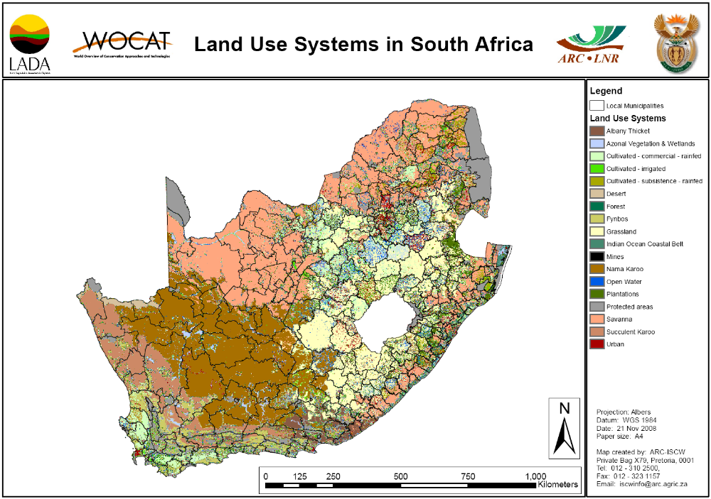
For the WOCAT-LADA-DESIRE mapping exercise, the land use system (LUS) is considered as the basic unit of evaluation (Nachtergaele et al, 2007). A global map of land use systems is available, but this map needs refinement and adjustments at national level in order to provide appropriate national units in which land degradation and conservation can be described and evaluated. These basic LUS units contain a wealth of information (biophysical as well as socio-economical) related to land use and land use practices which are the major causes of land degradation.

Figure 1: Example of a base map with land use systems and administrative units from South Africa.

The LUS units in combination with administrative units permit the user to evaluate trends and changes in time of the land degradation and conservation practices applied. An example of the LUS units combined with administrative units is presented in Figure 1. Each LUS within an administrative unit constitutes a unique mapping unit (see Figure 2) for which information on degradation and conservation should be provided in the matrix tables (one table per mapping unit, see Q2-3). Note that each mapping unit has one clearly defined LUS, but the same LUS may occur in other administrative¹ units and hence form additional mapping units.

The basic unit of evaluation: The Land Use System (LUS)
For the delineation of the LUS the following criteria have been established:

LUS delineation criteria (compulsory):
- Land cover type (cropland, grassland, forest, wetlands, open water, bare areas and urban land)
- Land use type: no use, protected use, urban, large scale irrigated areas, combination of cropland and livestock (agro-pastoralism), if available livestock density class (no, low, moderate, high)

LUS delineation criteria and attributes (additional/ optional):
- Land use attributes: e.g. dominant crop type/group, livestock type, small scale irrigation, input level.
- Biophysical attributes: e.g. slope, soil type, moisture availability (infiltration , runoff), altitude, temperature regime, highland and mountain ecosystems and climatically determined ecosystems.
- Socio economic attributes: e.g. population density, poverty indicator.

Specific National LUS delineation criteria and attributes that may be added (if available)
- Farm size, tenure and organization (commercial or subsistence)
- Fertilizer use and mechanization (if known)
- Water resources (if known)
- Forest management (if known)

Refer to Annex 1 for table with LUS

The LADA project provides free of charge the various GIS layers for the LUS delineation criteria mentioned above with a resolution of 5 arc minutes, which can be adapted, refined and expanded nationally. Please contact: LADA-Secretaria@fao.org

Land use systems and their attributes include many important parameters related directly to land degradation and soil and water conservation. Soil erosion on forest land, for instance, may require different soil and water conservation measures than degradation on cultivated land.

A detailed explanation for constructing LUS globally (Nachtergaele et al, 2007; George and Petri, 2006) is published separately. An example of the national LUS creation is published for South Africa (Pretorius et al., 2007).

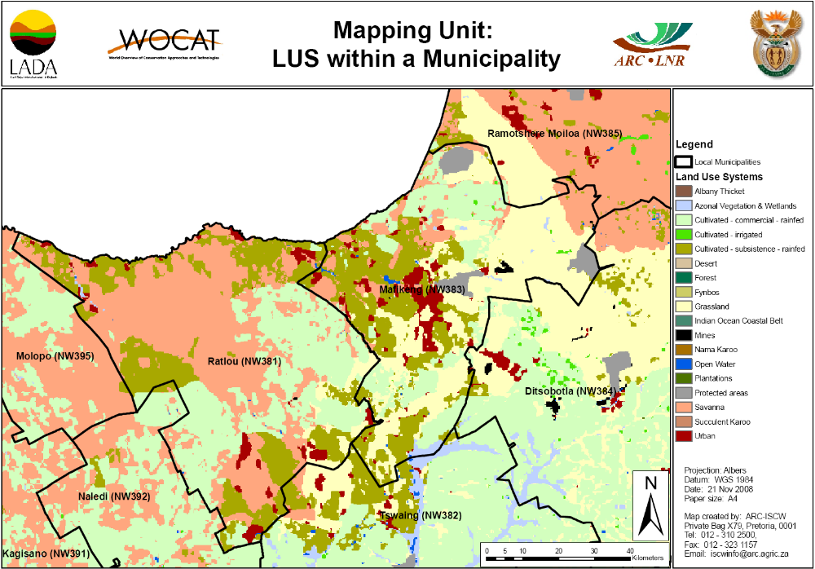
Figure 2: A Mapping Unit consists of a LUS within a Municipality e.g. the pink coloured area called Savanna (LUS) in Ratlou municipality (administrative unit) (example from South Africa).

Where no LUS map is available or not at the appropriate scale for a study site, any other land use map can be used as a base map.

Steps of data collection
The following steps will guide you through the process of collecting the necessary data. Each step first lists what needs to be done, followed by detailed explanations. Data may be entered in two ways: either directly in the database by clicking on a unit or as hard copy on the attached matrix tables, which then can be entered in the interactive map database which allows visualization and easy adjustments of the results. In any case, for harmonization and quality assurance sake, the assessment needs to be done in teams of experts. It is recommended to complete each step for all mapping units before moving to the next step. Alternatively you can complete the whole questionnaire for one mapping unit before moving to the next.

Step 1: Contributing specialists
Data collection, harmonization and quality assurance should be done in a team of specialists. National specialists involved in this exercise should cover an array of subjects related to land degradation, land management, land use and soil and water conservation in the country.

What needs to be done?

Fill out the information on Q1 (Annex 1) or enter it directly in the database.

Step 2: Land use system (LUS)

What needs to be done?
a) Estimate the increase or decrease in area over the past 10 years for each LUS within the administrative unit concerned.
b) Similarly, give your best estimate of decrease or increase in the intensity of each land use system.

Explanations concerning step 2:
Select the LUS mapping unit for which the information on land degradation and conservation is to be filled in. For definition of a mapping unit refer to E1.

Note: Information that is contained in that specific unit will be displayed in the database system and contains the unit delineation (the boundaries of the system) and an optional number of attributes consisting of ecosystem and socio-economic parameters.
- Area trend of the LUS (Direct driver)
Changes in land use area may be an important factor in soil degradation assessment and evaluation of conservation activities. Note that if the area for one or several LUS is increasing, this will be at the expense of one or several other LUS, which should show a decreasing area trend. Consider the increase or decrease in area over approximately the past 10 years.
The changes in area extent of the LUS are represented by the following five classes:
2: area coverage is rapidly increasing in size; i.e. > 10% of the LUS area/10 years
1: area coverage is slowly increasing in size, i.e. < 10% of the LUS area/10 years
0: area coverage remains stable
-1: area coverage is slowly decreasing in size, i.e. < 10% of the LUS area/10 years
-2: area coverage is rapidly decreasing in size, i.e. > 10% of that specific LUS area/10 years
- Land use intensity trends (Direct driver)
A change in the intensity of land use is another significant trend with respect to land degradation and conservation. It is expressed through changes in inputs, management, or number of harvests in crop based systems, the introduction of rotational grazing and fencing for instance in grazing lands or the introduction of paved roads in urban systems. The estimate required is to cover the period of approximately the last 10 years.

Only changes within the same land use system are to be considered here - not changes from one land use system to another!
2: Major increase: e.g. from manual labour to mechanisation, from low external inputs to high external inputs, etc.
1: Moderate increase, e.g. a switch from no or low external inputs to some fertilizers/pesticides; switch from manual labour to animal traction.
0: No major changes in inputs, management level, etc.
-1: A moderate decrease in land use intensity, e.g. a slight reduction of external inputs.
-2: A major decrease in land use intensity, e.g. from mechanisation to manual labour, or a large reduction of external inputs.

- Remarks
Indicate relevant information related to land use, its area and intensity change. Of special importance are reasons for intensity trend.

Table 1: Land use system (Example)
Name: ____First name Last name_____________ Country: __South Africa
Mapping Unit Id (LUS + admin. unit): 113 (Savanna + Ratlou municipality)

Land Use System (Step2)
a) LUS area trend | b) LUS intensity trend | c) Remarks (e.g. reasons for trend)
2 | 1 | Increased grazing pressure due to growing numbers of livestock

Step 3: Land degradation per land use system

What needs to be done?
a) Determine the major types of land degradation (including overlaps of degradation types) presently occurring under each land use system.
- Give the current extent of the identified land degradation types or overlaps as a percentage of the land use system area.
- Indicate the current degree of land degradation for the types or overlaps identified.
- Estimate the rate of land degradation over the past 10 years.
- Indicate the direct causes of land degradation.
- Indicate the indirect causes of land degradation.
- Estimate the impact on ecosystem services for the identified degradation types or overlaps.
Explanations concerning step 3:
Prior to evaluating the distribution of conservation activities (response indicators) it is important to have an impression of the extent and degree of current land degradation (state indicators) necessitating these measures. Although natural degradation is not excluded, emphasis is placed on degradation caused by human activities.

It is not the intention to capture all manifestations of degradation. It is important to focus on the major ones – in terms of extent and/or impact. If more than one occur it is important to focus on the different major types that may occur rather than on subtypes.

In the case of different degradation types affecting the same area within a LUS, these can be indicated as overlapping up to a maximum of three types per overlap (indicated as i, ii, iii horizontally in example of Table 2: Ha, Pc). The other attributes such as extent, degree etc. should be indicated for the overlap as a whole, not for the individual constituting types. Degradation types occurring in different areas of the LUS should be listed vertically. See example of Table 2: Ha/Pc as first (overlapping) type occurring in one area of the LUS, Bs as second type occurring in another area of the LUS (see also Figure 3).

Note: Experience in collecting data on degradation has shown that there is a tendency to overestimate the extent and the degree of degradation. Objective judgements should be made as far as possible!
- Types of land degradation (State indicators)

O: No degradation

W: Soil erosion by water
Wt: Loss of topsoil / surface erosion
Loss of topsoil through water erosion is a process of more or less even removal of topsoil, generally known as surface wash or sheet / interrill erosion. Wt also includes tillage erosion. As nutrients are normally concentrated in the topsoil, the erosion process leads to impoverishment of the soil. Loss of topsoil itself is often preceded by compaction and/or crusting, causing a decrease in infiltration capacity of the soil, and leading to accelerated runoff and soil erosion.
Wg: Gully erosion / gullying
Development of deep incisions down to the subsoil due to concentrated runoff.
Wm: Mass movements / landslides
Examples of this degradation type are landslides and mudflows, which occur locally but often cause heavy damage.
Wr: Riverbank erosion
Lateral erosion of rivers cutting into riverbanks.
Wc: Coastal erosion
Abrasive action of waves along sea or lake coasts.
Wo: Offsite degradation effects
Deposition of sediments, downstream flooding, siltation of reservoirs and waterways, and pollution of water bodies with eroded sediments.

E: Soil erosion by wind
Et: Loss of topsoil
This degradation type is defined as the uniform displacement of topsoil by wind action. It is a widespread phenomenon in arid and semi-arid climates, but it also occurs under more humid conditions. Wind erosion is nearly always caused by a decrease in the vegetative cover of the soil. In (semi)arid climates natural wind erosion is often difficult to distinguish from human-induced wind erosion, but natural wind erosion is often aggravated by human activities.
Ed: Deflation and deposition
Uneven removal of soil material by wind action. Leads to deflation hollows. It can be considered as an extreme form of loss of topsoil, with which it usually occurs in combination.
Eo: Offsite degradation effects
Covering of the terrain with windborne particles from distant sources ("overblowing"). Includes air pollution from mining activities e.g. mining dust, asbestos etc.

C: Chemical soil deterioration
Cn: Fertility decline and reduced organic matter content
Aside from loss of nutrients and reduction of organic matter as a result of topsoil removal by erosion, a net decrease of available nutrients and organic matter in the soil may also occur due to “soil mining”: nutrient outputs (through harvesting, burning, leaching, etc.) are not or insufficiently compensated by inputs of nutrients and organic matter (through manure / fertilizers, returned crop residues, flooding). This type also includes nutrient oxidation and volatilisation.
Ca Acidification
Lowering of the soil pH, eg due to acidic fertilisers or atmospheric deposition.
Cp: Soil pollution
Contamination of the soil with toxic materials. This may be from local (e.g. waste dumps) or diffuse sources (atmospheric deposition).
Cs: Salinisation / alkalinisation
A net increase of the salt content of the (top)soil leading to a productivity decline.

P: Physical soil deterioration
Pc: Compaction
Deterioration of soil structure by trampling or the weight and/or frequent use of machinery.
Pk: Sealing and crusting
Clogging of pores with fine soil material and development of a thin impervious layer at the soil surface obstructing the infiltration of rainwater. Development of a water-repellent layer (eg beneath surface ashes after forest fire).
Pw: Waterlogging
Effects of human induced water saturation of soils (excluding paddy fields).
Ps: Subsidence of organic soils, settling of soil
Drainage of peatlands or low lying heavy soils.
Pu: Loss of bio-productive function due to other activities
Some land use changes (e.g. construction, mining) may have implications for the biological and productive function (e.g. agricultural production) of the soil and hence a degradation effect.

H: Water degradation
Ha: Aridification
Decrease of average soil moisture content (reduced time to wilting, change in phenology, lower yield).
Hs: Change in quantity of surface water
Change of the flow regime: flood / peak flow, low flow, drying up of rivers and lakes.
Hg: Change in groundwater / aquifer level
Lowering of groundwater table due to over-exploitation or reduced recharge of groundwater; or increase of groundwater table e.g. due to excessive irrigation resulting in waterlogging and/or salinisation.
Hp: Decline of surface water quality
Increased sediments and pollutants in fresh water bodies due to point pollution (direct effluents eg from industry, sewage and waste water in river water bodies) and land-based pollution (pollutants washed into water bodies due to land management practices eg sediments, fertilizers and pesticides).
Hq: Decline of groundwater quality
Due to pollutants infiltrating into the aquifers. Human induced pollution is mainly caused by inappropriate land management practices or deposition of waste.
Hw: Reduction of the buffering capacity of wetland areas
To cope with flooding and pollution.

B: Biological degradation
Bc: Reduction of vegetation cover
Increase of bare / unprotected soil (including duration of exposure).
Bh: Loss of habitats
Decreasing vegetation diversity (fallow land, mixed systems, field borders).
Bq: Quantity / biomass decline
Reduced vegetative production for different land use (e.g. on forest land through clear felling, secondary vegetation with reduced productivity).
Bf: Detrimental effects of fires
On forest (eg slash and burn), bush, grazing and cropland (burning of residues). This includes low severity (“cold”) fires (only understory burns, trees survive) and high severity (“hot”) fires (reach the crown of the trees and may kill them).
Bs: Quality and species composition / diversity decline
Loss of natural species, land races, palatable perennial grasses; spreading of invasive, salt-tolerant, unpalatable, species / weeds.
Bl: Loss of soil life
Decline of soil macro-organisms (earthworms and termites) and micro-organisms (bacteria and fungi, …) in quality and quantity.
Bp: Increase of pests / diseases
Reduction of biological control (e.g. trough loss or predators).

- Extent of the degradation type: area percentage of mapping unit (State indicator)
For each identified land degradation type, the extent should be given as percentage of the LUS affected by that degradation type within the selected administrative unit. In the example below of the Ratlou municipality in South Africa, 10% of the grassland within the municipality is affected by bush encroachment (Bs), and another 15% is affected by an overlap of both aridification (Ha) and compaction (Pc). The latter combination of Ha and Pc must be indicated as a separate type! The total extent indicated should the be 25% (10+15) for the entire mapping unit (see Figure 3).

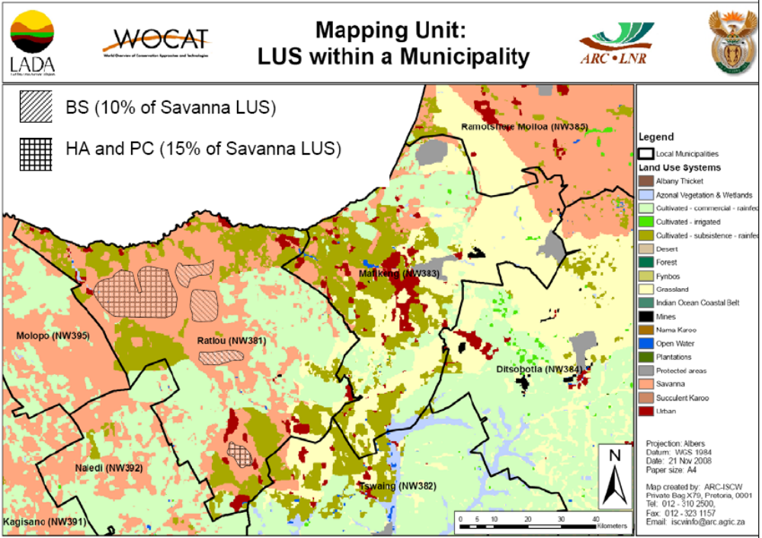
Figure 3: Shows selected degradation types (shaded areas) and combinations within the LUS Savanna in the Ratlou municipality (South Africa). In this mapping unit 10 % of the LUS is affected by bush encroachment (Bs ) and 15 % by a combination (overlap) of aridification (Ha) and compaction (Pc). (see also Table 2)

NOTE: The maps generated from this information will NOT show the real field situation picture as above – with degradation exactly localised within the LUS – but will only reflect the percentage of that LUS that is affected by a specific degradation type.
- Degree of land degradation (State indicator)
Degree is defined here as the intensity of the land degradation process, e.g. in the case of soil erosion: the amount of soil washed or blown away. Indicators of land degradation are used to measure the degree of degradation, e.g. the percentage of the total topsoil lost, the percentage of total nutrients and organic matter lost, the relative decrease in soil moisture holding capacity, shift in vegetation cover, decreasing ground water table etc. For the assessment of the degree of degradation, the following qualitative categories are used. In case a degradation type has different degrees of degradation within the same land use system in a mapping unit it can be split up and listed separately in two rows (e.g. Wt: extent 10% with degree 4; Wt: extent 40% with degree 1).

  - Light: there are some indications of degradation, but the process is still in an initial phase. It can be easily stopped and damage repaired with minor efforts.
  - Moderate: degradation is apparent, but its control and full rehabilitation of the land is still possible with considerable efforts.
  - Strong: evident signs of degradation. Changes in land properties are significant and very difficult to restore within reasonable time limits.
  - Extreme: degradation beyond restoration.
- Rate of degradation (State indicator)
Whereas the degree of degradation indicates the current static situation, the rate indicates the trend of degradation over a recent period of time. A severely degraded area may be quite stable at present (i.e. low rate, hence no trend towards further degradation), whereas some areas that are now only slightly degraded may show a high rate, hence a trend towards rapid further deterioration. At the same time an identification of the rate of degradation can reveal areas where the situation is improving (through soil and water conservation measures, for instance). The average development over approximately the last 10 years should be assessed in order to level out irregular developments. Three classes are defined that show a trend towards further deterioration, and three with a trend towards decreasing degradation either as a result of human influence or natural stabilisation; one class indicates no changes.

3: rapidly increasing degradation
2: moderately increasing degradation
1: slowly increasing degradation
0: no change in degradation
-1: slowly decreasing degradation
-2: moderately decreasing degradation
-3: rapidly decreasing degradation
- Direct causes of land degradation (direct pressure indicators)
Various types of human activities and natural causes may lead to land degradation. The emphasis in the degradation inventory is on human-induced degradation, but sometimes natural degradation also necessitates measures to be taken. More than one of the following causes (direct pressure indicators) may be entered in the matrix table.

s: Soil management: improper management of the soil including:
(s1) cultivation of highly unsuitable / vulnerable soils
(s2) missing or insufficient soil conservation / runoff and erosion control measures
(s3) heavy machinery (including timing of heavy machinery use)
(s4) tillage practice (ploughing, harrowing, etc.)
(s5) others (specify under column h - Remarks)
c: Crop and rangeland management: improper management of annual, perennial (e.g. grass), shrub and tree crops. This includes a wide variety of practices:
(c1) reduction of plant cover and residues (including burning, use for fodder, etc.)
(c2) inappropriate application of manure, fertilizer, herbicides, pesticides and other agro-chemicals or waste (leading to contamination and washing out (non-point pollution))
(c3) nutrient mining: excessive removal without appropriate replacement of nutrients
(c4) shortening of the fallow period in shifting cultivation
(c5) inappropriate irrigation (full and supplementary): inefficient irrigation method, over-irrigation, insufficient drainage, irrigation with salty water
(c6) inappropriate use of water in rainfed agriculture (eg excessive soil evaporation and runoff
(c7) bush encroachment and bush thickening
(c8) occurrence and spread of weeds and invader plants
(c9) others (specify under column h) Remarks)

f: Deforestation and removal of natural vegetation: extensive removal of natural vegetation (usually primary or secondary forest), due to:
(f1) large-scale commercial forestry,
(f2) expansion of urban / settlement areas and industry
(f3) conversion to agriculture
(f4) forest / grassland fires
(f5) road and rail construction
(f6) others (specify under column h) Remarks)
Deforestation is often followed by other activities that may cause further degradation.
e: Over-exploitation of vegetation for domestic use: in contrast to "deforestation and removal of natural vegetation", this causative factor does not necessarily involve the (nearly) complete removal of "natural" vegetation, but rather degeneration of the remaining vegetation, thus leading to insufficient protection against land degradation. It includes activities such as:
(e1) excessive gathering of fuel wood, (local) timber, fencing materials
(e2) removal of fodder
(e3) others (specify under column h) Remarks)
g: Overgrazing: usually leads to a decrease in plant cover, a change to lower quality fodder, and/or soil compaction. This may in turn cause reduced soil productivity and water or wind erosion. It includes:
(g1) excessive numbers of livestock
(g2) trampling along animal paths
(g3) overgrazing and trampling around or near feeding, watering and shelter points
(g4) too long or extensive grazing periods in a specific area or camp leading to overutilization of palatable species
(g5) change in livestock composition: from large to small stock; from grazers to browsers; from livestock to game and vice versa
(g6) others (specify under column h) Remarks)
i: Industrial activities and mining: includes all adverse effects arising from industrialisation and extractive activities, such as loss of land resource and their functions for agriculture, water recharge, etc.. It includes land used for:
(i1) industry
(i2) mining
(i3) waste deposition
(i4) others (specify under column h) Remarks)
u: Urbanisation and infrastructure development: includes all adverse effects arising from industrialisation and extractive activities, such as loss of land resources and their functions for agriculture, water recharge. It can cause considerable run-off on neighbouring areas, causing accelerated damage like erosion, as well as other types of degradation (eg pollution). It includes land used for:
(u1) settlements and roads
(u2) (urban) recreation
(u3) others (specify under column h) Remarks)
p: Discharges leading to point contamination of surface and ground water resources, or excessive runoff in neighbouring areas:
(p1) sanitary sewage disposal
(p2) waste water discharge
(p3) excessive runoff
(p4) poor and insufficient infrastructure to deal with urban waste (organic and inorganic waste)
(p5) others (specify under column h) Remarks)
q: Release of airborne pollutants from industrial activities, mining and urbanisation leading to:
(q1) contamination of vegetation/ crops and soil
(q2) contamination of surface and ground water resources:
(q3) others (specify under column h) Remarks)
w: Disturbance of the water cycle leading to accelerated changes in the water level of ground water aquifers, lakes and rivers (improper recharge of surface and ground water) due to:
(w1) lower infiltration rates / increased surface runoff
(w2) others (specify under column h) Remarks)
o: Over-abstraction / excessive withdrawal of water:
(o1) irrigation
(o2) industrial use
(o3) domestic use
(o4) mining activities
(o5) decreasing water use efficiency
(o6) others (specify under column h) Remarks)
n: Natural causes: many occurrences of degradation are not caused by human activities. Although this assessment places the emphasis on human-induced degradation, natural causes may be indicated as well if of major importance. They include:
(n1) change in temperature
(n2) change of seasonal rainfall
(n3) heavy/extreme rainfall (intensity and amounts)
(n4) windstorms / dust storms
(n5) floods
(n6) droughts
(n7) topography
(n8) other natural causes (avalanches, volcanic eruptions, mud flows, highly susceptible natural resources, etc.)

- Indirect causes of land degradation (indirect pressure indicators)
Socio-economic factors are often crucial in order to understand why land degradation occurs. They are the driving forces of the direct causes of land degradation. More than one of the following indirect causes may be entered in the matrix table:

p: Population pressure: density of population can be a driving force for degradation. High population pressure may trigger or enhance degradation, e.g. by competing for scarce resources or ecosystem services, but a low population density may also lead to degradation, for instance where it leads to a lack of labour force.
c: Consumption pattern and individual demand: a change in the consumption pattern of the population and in the individual demand for natural resources (e.g. for agricultural goods, water, land resources, etc.) leading to degradation.
t: Land Tenure: Poorly defined tenure security / access rights may lead to land degradation, as individual investments in maintenance and enhancement can be captured by others and land users do not feel “owner” of the maintenance investments. Tenure systems are particular important factors when conservation practices have a long lag between investment and return, such as terracing and tree planting.
h: Poverty: poor people cannot afford to invest in resource conserving practices, so instead they continue to use inappropriate farming practices (such as ploughing hillsides and overgrazing), which again will lead to increased land degradation and worsen poverty. Whether poverty plays a role in land degradation needs to be assessed. It also includes situations where the need for bigger profits leads to over-exploitation and degradation of natural resources.
l: Labour Availability: Shortage of rural labour (eg through migration, prevalence of diseases) can lead to abandonment of traditional resource conservation practices such as terrace maintenance. Off-farm employment opportunities may, on the other hand, help to alleviate pressure on production resources, in the sense that land users can invest more in conservation infrastructure as income increases.
r: Inputs and infrastructure (roads, markets, distribution of water points, etc.): inaccessibility to, or high prices for key agricultural inputs such as fertilizers, may render it difficult or unprofitable to preserve soil fertility or water resources. Access to markets and prices and good infrastructure may improve this. On the other hand, a road through a forest can lead to overexploitation and degradation.
e: Education, awareness raising and access to knowledge and support services and loss of knowledge: investing in human capital is one of the keys in reducing poverty (and thus land conservation practices). Educated land users are more likely to adopt new technologies. Land users with education often have higher returns from their land. Education also provides off-farm labour opportunities.
w: War and conflict: they lead to reduced options to use the land or to increased pressure.
g: Governance, institutions and politics: laws and enforcements, organization, collaboration and support: government induced interventions may set the scene and be indirect drivers for implementation of conservation interventions.
o: Others (specify under column h) Remarks)
- Impact on ecosystem services (Impact indicator)
The same degree of land degradation can have different impacts in different places: e.g. removal of a 5 cm layer of soil may have a greater impact on a poor shallow soil than on a deep fertile soil. Similarly, the reduction of water availability in a semi-arid environment has much higher impacts on humans and livestock than a similar reduction in a humid environment. The main impact to be assessed here is the effect on ecosystem services (ES) as derived from the Millennium Ecosystem Assessment (World Resources Institute, 2005). We need to assess the impact in areas with land degradation compared to areas without land degradation (e.g. areas that are already well conserved).

The effects of degradation can be partially hidden by various measures, such as the use of fertilizers or the treatment of polluted water. In this case, parts of these inputs are in fact used to compensate for the productivity loss caused by soil erosion and nutrient loss or for the loss of water quality respectively. Therefore, the impact of land degradation needs to be assessed in consideration of these responses. Conversely, other factors that are not related to degradation may contribute to yield declines (e.g. pests and diseases, weather influences). When considering the impact of degradation over a longer period (e.g. 10 years) such influences will mostly be levelled out. For each mapping unit, assess the type of impact on ecosystem services (ES) according to the classes below.

Type of impact (selected from Millennium Ecosystem Assessment):

P Productive services
(P1) production (of animal / plant quantity and quality including biomass for energy) and risk
(P2) water (quantity and quality ) for human, animal and plant consumption
(P3) land availability (area of land for production per person)
(P4) others (specify under column h) Remarks)

E Ecological services (regulating / supporting) and indicators*
a) Water services:
(E1) regulation of excessive water such as excessive rains, storms, floods eg affecting infiltration, drainage, runoff, evaporation, etc.
(E2) regulation of scarce water and its availability eg during dry seasons, droughts affecting water and evaporation loss, etc.
b) Soil services:
(E3) organic matter status
(E4) soil cover (vegetation, mulch, etc.)
(E5) soil structure: surface (eg sealing and crusting) and subsoil affecting infiltration, water and nutrient holding capacity, salinity etc.
(E6) nutrient cycle (N, P, K) and the carbon cycle (C)
(E7) soil formation (including wind-deposited soils)
c) Biodiversity:
(E8) biodiversity
d) Climate services:
(E9) greenhouse gas emission (CO₂, methane, etc.)
(E10) (micro)-climate (wind, shade, temperature, humidity)
(E11) others (specify under column h) Remarks)

S Socio-cultural services / human well-being and indicators
(S1) spiritual, aesthetic, cultural landscape and heritage values, recreation and tourism,
(S2) education and knowledge (including indigenous knowledge)
(S3) conflict transformation
(S4) food & livelihood security and poverty
(S5) health
(S6) net income
(S7) protection / damage of private and public infrastructure (buildings, roads, dams, etc.)
(S8) marketing opportunities (access to markets, etc.)
(S9) others (specify under column h) Remarks)

For each type indicate the code and add the level from 1 to -3 (e.g. P1-2: for high negative impact on production) according to the following definitions. Note that there may also be positive impacts of land degradation, e.g. erosion in one place can lead to accumulation of fertile sediments further downslope or downstream.

Level of impact:
-3 high negative impact: land degradation contributes negatively (more than 50%) to changes in ES
-2 negative impact: land degradation contributes negatively (10-50%) to changes in ES
-1 low negative impact: land degradation contributes negatively (0-10-%) to changes in ES.
1 low positive impact: land degradation contributes positively (0-10%) to the changes in ES
2 positive impact: land degradation contributes positively (10-50%) to the changes in ES
3 high positive impact: land degradation contributes positively (more than 50%) to changes in ES.
- Remarks
Indicate relevant additional information related to land degradation. E.g. when you indicated a category ‘others’ (e.g. under overgrazing g3) describe it further (see example below).

See example in Table 2 below.

Table 2: Land degradation (Example)

Name: ____X Y_______________________ Country: __South Africa
Mapping Unit Id (LUS + admin. unit): 113 (Savanna + Ratlou municipality)

Land degradation (Step 3)
a) Type (state) |  |  | b) Extent | c) Degree | d) Rate | e) Direct causes | f) Indirect causes | g) Impact on ecosystem services | h) Remarks
i | ii | iii
Ha | Pc |  | 15% | 2 | 1 | g1, e1, f4, | p, h, t | P1-3, E2-2 | Degradation is concentrated in NW communal grazing are of District
Bs |  |  | 10% | 2 | -3 | g1, g3 | e, g | P1-2, S3-1 | g3: change of livestock composition from large to small stock

Step 4: Land conservation (Response indicators)

What needs to be done?
- Give the name of the most widespread technologies (single or combinations) for each mapping unit.
- Assign each technology identified under (a) to a Conservation group described below or in Annex 1.
- Categorize each technology according to the conservation measures: agronomic, vegetative, structural, management including combinations
- Indicate whether the technology has been implemented with the purpose of prevention, mitigation and /or rehabilitation of land degradation
- Indicate the extent of each technology as a area percentage of the mapping unit (land use system area within the administrative unit).
- Indicate degradation addressed by the conservation measures
- Estimate the "effectiveness" class for the identified technologies per land use system unit.
- Indicate any trends towards higher or lower effectiveness of conservation.
- Indicate the impact on ecosystem services (type and level)
- Indicate when each technology was installed.
- Give a reference to one or more WOCAT questionnaires on SLM Technologies (QT) that describe the technologies listed under a). If no QT is available for a specific technology, give some concise details on the back of the table for the hard copy or under “Remarks” in the database.
Explanations concerning step 4:
While the questionnaires on SLM Technologies (QT) and on SLM Approaches (QA) collect detailed information on conservation activities, this map questionnaire is intended to provide the information necessary to obtain a geographical display of some important conservation data. Wherever you can make a reference to relevant QTs, more background information will be available (see i, below).

Note: Experience in collecting data on SLM has shown that there is a tendency to overestimate the extent and the effectiveness of conservation. Objective judgements should be made as far as possible!
- Name of the Technology

Provide a commonly used name (preferably not a local name) for the most widespread (not necessarily the most effective!) technologies applied within each land use system unit. NB: Only up to four possible technologies per LUS are numbered in the hard copy matrix table, but more technologies for the same polygon may be entered on the reverse side or on another sheet. In the database version the number of technologies to be entered per LUS is not restricted.
- Conservation groups

The technologies are clustered into conservation groups:
CA: Conservation agriculture / mulching (mainly agronomic measures):
Conservation agriculture is characterised by systems incorporating three basic principles: minimum soil disturbance, a degree of permanent soil cover, and crop rotation.
NM: Manuring / composting / nutrient management (mainly agronomic measures):
Organic manures, composts, green manure, mineral fertilizers / soil conditioners are intended to improve soil fertility, and simultaneously enhance soil structure (against compaction and crusting) and improve water infiltration and percolation.
RO: Rotational system / shifting cultivation / fallow /slash and burn
This system is characterized though the rotation of rather different land management such a few years of intensive crop production followed or by a period of low intensity use allowing natural regrowth (fallow) or replanting of grasses, legumes, trees etc. and then followed by intensive use and clearing of the vegetation.
Shifting cultivation is an agricultural system in which plots of land are cultivated temporarily, then abandoned. This system often involves clearing of a piece of land followed by several years of wood harvesting or farming until the soil loses fertility. Once the land becomes inadequate for crop production, it is left to be reclaimed by natural vegetation, or sometimes converted to a different long term cyclical farming practice. Slash and burn refers to the cutting and burning of forests or woodlands to create fields for agriculture or pasture for livestock, or for a variety of other purposes
VS Vegetative strips / cover (mainly vegetative measures):
Grasses or trees are used in various ways. In the case of strips, these often lead to the formation of bunds and terraces due to ‘tillage erosion’ – the downslope movement of soil during cultivation. In the other cases, the effect of dispersed vegetation cover is multiple, including increasing ground cover, improving soil structure, and infiltration, as well as decreasing erosion by water and wind.
AF Agroforestry (mainly vegetative, combined with agronomic)
Agroforestry describes land use systems where trees are grown in association with agricultural crops, pastures or livestock – and there are usually both ecological and economic interactions between components of the system. There is a wide range covered: from shelterbelts, to trees with coffee, to multi-storey cropping.
AP Afforestation and forest protection
Replanting of forests, improved forest, protection against fires, improved management of forest use and felling of trees are part of this group.
RH Gully control / rehabilitation (structural combined with vegetative)
Gully control encompasses a set of measures that address this specific and severe type of erosion, where land rehabilitation is required. There is a whole range of different and complementary measures, though structural barriers dominate – often stabilised with permanent vegetation. Includes mining rehabilitation, top soil storage, sloping and revegetation.
TR Terraces (structural, but often combined with vegetative and agronomic measures)
There is a wide variety of different terrace types, from forward-sloping terraces to level or backward-sloping bench terraces, with or without drainage systems. Irrigated terraces (usually for paddy rice) are a special case in terms of water management and its implications for terrace design.
GR Grazing land management (management practices with associated vegetative and agronomic measures)
Improved management of grazing land relates to changing control and regulation of grazing pressure. It is associated with an initial reduction of the grazing intensity through fencing, followed either by rotational grazing, or ‘cut-and-carry’ of fodder, and vegetation improvement and management change.
WH Water harvesting (structural, but also combined)
Water harvesting is the collection and concentration of rainfall runoff for crop production – or for improving the performance of grass and trees – in dry areas where moisture deficit is the primary limiting factor.
SA: Groundwater / salinity regulation / water use efficiency
All measures that lead to an improved regulation of the water cycle, reducing flood, flows, improving water infiltration in the soil and the recharge of the groundwater tables or in case of salinity to lower ground water tables, and improve water availability and water quantity. This includes improved irrigation techniques such as the use of drip irrigation.
WQ: Water quality improvements : (structural, management and vegetative)
Measures that primarily aim at improving water quality such as through sedimentation traps, filter / purification system, infiltration ponds.
SD: Sand dune stabilization: (vegetative, structural and management)
Fixing surfaces from being blown and transported by wind, such as sand dunes, light structured soils (e.g. as loess soils. The aim can be to reduce the material from being blown and / or to stop the shifting of dunes. Also includes stabilization of mine dumps.
CB: Coastal bank protection: (vegetative, structural and management)
Measure that protect land and infrastructure from water erosion and impact of waves.
PR: Protection against natural hazards: flood, storms, earth quakes, stone fall, avalanches, land slides, mudflows
SC: Storm water control, road runoff: (structural, vegetative, management)
Measure that are designed for extreme events such as flood flows and for coping with the runoff caused by sealed surfaces like roads, industrial areas, parking places, etc.
WM: Waste management: Organic and inorganic waste management, include solid waste (sewerage), rubble littering, effluent tailings, bio-waste and chemical waste
CO: Conservation of natural biodiversity: Conservation of natural ecosystems and processes and the conservation of rare and endangered species.
OT: Other: (specify under column l) Remarks)
- Conservation measures
Choose the conservation measures that correspond to the technologies identified under (a). Annex 1 indicates the conservation measures and definitions. Often several measures are combined in the same technology (see Figure 4). In that case, list the categories for these measures according to their importance (the dominant one first), up to a maximum of 3 land degradation types and 4 conservation measures (see Table 3 for the example of one technology).

If more than one SLM Technology (consisting of one or more categories each) is indicated for the same land use system mapping unit, they are considered to be covering different areas, i.e. not to be mutually overlapping. If two or more conservation measures are overlapping the technology is a combination. See Table 3 for an example of a field situation for a single polygon and how to map it.
- Purpose: prevention, mitigation and /or rehabilitation of land degradation

Indicate what purpose the SLM Technologies address most :

P Prevention implies the use of conservation measures that maintain natural resources and their environmental and productive function on land that may be prone to degradation. The implication is that good land management practice is already in place: it is effectively the antithesis of human-induced land degradation.

M Mitigation: is intervention intended to reduce ongoing degradation. This comes in at a stage when degradation has already begun. The main aim here is to halt further degradation and to start improving resources and their functions. Mitigation impacts tend to be noticeable in the short to medium term: this then provides a strong incentive for further efforts. The word ‘mitigation’ is also sometimes used to describe reducing the impacts of degradation.

R Rehabilitation: is required when the land is already degraded to such an extent that the original use is no longer possible, and land has become practically unproductive. Here longer-term and more costly investments are needed to show any impact.

Figure 4: Categories (measures) of conservation

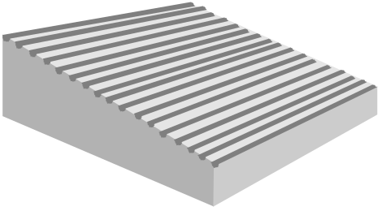 | A: Agronomic measures such as mixed cropping, contour cultivation, mulching, etc.  - are usually associated with annual crops  - are repeated routinely each season or in a rotational sequence  - are of short duration and not permanent  - do not lead to changes in slope profile  - are normally independent of slope
A1: Vegetation / soil cover
A2: Organic matter / soil fertility
A3: Soil surface treatment
A4: Subsurface treatment
A5: Others
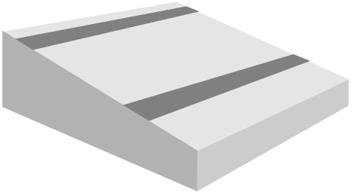 | V: Vegetative measures such as grass strips, hedge barriers, windbreaks, etc.  - involve the use of perennial grasses, shrubs or trees  - are of long duration  - often lead to a change in slope profile  - are often zoned on the contour or at right angles to wind direction  - are often spaced according to slope
V1: Tree and shrub cover
V2: Grasses and perennial herbaceous plants
V3: Clearing of vegetation (eg fire breaks/reduced fuel)
V4: Others
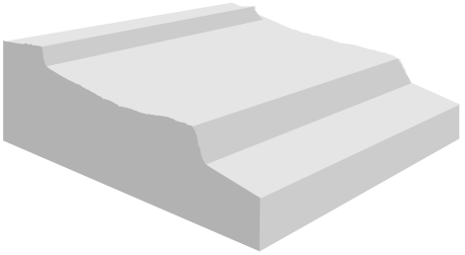 | S: Structural measures such as terraces, banks, bunds, constructions, palisades, etc.  - often lead to a change in slope profile  - are of long duration or permanent  - are carried out primarily to control runoff, wind velocity and erosion  - often require substantial inputs of labour or money when first installed  - are often zoned on the contour / against wind direction  - are often spaced according to slope  - involve major earth movements and / or construction with wood, stone, concrete, etc.
S1: Bench terraces (slope of terrace bed<6%)
S2: Forward sloping terraces (slope of terrace bed>6%)
S3: Bunds / banks
S4: Graded ditches / waterways (to drain and convey water)
S5: Level ditches / pits
S6: Dams / pans: store excessive water
S7: Reshaping surface (reducing slope)
S8: Walls / barriers / palisades
S9: Others

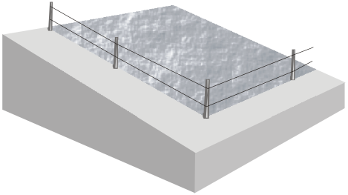 | M: Management measures such as land use change, area closure, rotational grazing, etc.  - involve a fundamental change in land use  - involve no agronomic and structural measures  - often result in improved vegetative cover  - often reduce the intensity of use  M1: Change of land use type  M2: Change of management / intensity level  M3: Layout according to natural and human environment  M4: Major change in timing of activities  M5: Control / change of species composition (if annually or in a rotational sequence as done eg on cropland -> A1)  M6: Waste Management: Any measure which includes recycling, re-use or reduce: includes both artificial and natural methods for waste management  M7: Others
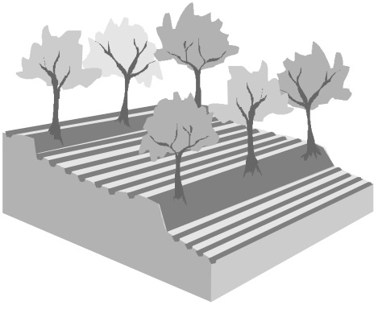 | Combinations in conditions where different measures are complementary and thus enhance each other’s effectiveness. Any combinations of the above measures are possible, eg:  - structural: terrace, with  - vegetative: grass and trees, with  - agronomic: ridges  Example: S1,V1, V2, A3
- Extent of SLM Technology: area percentage of mapping unit
Specify the area for each of the SLM Technologies as a percentage of the land use system area. The total area percentage for all SLM Technologies cannot be more than 100% for one mapping unit. As with degradation, (overlapping) combinations are considered separately (see Table 3 and Figure 5).
- Degradation addressed:
Specify the degradation type addressed by the SLM Technology. Use the degradation types listed under Step 3 a).
- Effectiveness of implemented SLM Technologies
The "effectiveness" of conservation measures is defined in terms of how much it reduces the degree of degradation, or how well it is preventing degradation.

4: Very high: the measures not only control the land degradation problems appropriately, but even improve the situation compared to the situation before degradation occurred. For example, soil loss is less than the natural rate of soil formation, while infiltration rate and/or water retention capacity of the soil, as well as soil fertility, are increased; only maintenance of the measures is needed. Either the measures have strongly improved water availability and quality (addressing water degradation), or vegetation cover and habitats have been highly improved (addressing biological degradation).
3: High: the measures control the land degradation problems appropriately. For example, soil loss does not greatly exceed the natural rate of soil formation, while infiltration rate and water retention capacity of the soil, as well as soil fertility, are sustained; only maintenance of the measures is needed. Concerning water and vegetation degradation, the measures are able to stop further deterioration, but improvements are slow.
2: Moderate: the measures are acceptable for the given situations. However, loss of soil, nutrients, and water retention capacity exceeds the natural or optimal (as with "high") situation. Besides maintenance, additional inputs are required to reach a "high" standard. Regarding water and vegetation degradation, the measures only slow down the degradation process, but are not sufficient.
1: Low: the measures need local adaptation and improvement in order to reduce land degradation to acceptable limits. Much additional effort is needed to reach a "high" standard.
- Effectiveness trend of SLM Technologies
SLM Technologies may become increasingly or decreasingly effective over time for various reasons, such as changes in land use or land use systems, changes in population density, ecological changes, etc. To assess whether a given practice is (still) appropriate under certain conditions, the trend in conservation effectiveness over the last 5-10 years is one suitable indicator.

1: increase in effectiveness: the measures have a growing positive impact on the reduction of degradation
0: no change in effectiveness
-1: decrease in effectiveness: the measures have less and less effect in reducing degradation, e.g. due to lack of maintenance
- Impact on ecosystem services
The main impact to be assessed here is the effect of SLM Technologies on ecosystem services (provisioning, regulating, supporting and cultural) as defined in the Millennium Ecosystem Assessment (World Resources Institute, 2005). We need to assess the impact in areas with the listed conservation measure compared to areas without conservation (e.g. areas that are degraded).

For each mapping unit, assess the type of impact according to the classes listed below.

P Productive Services
(P1) production (of animal / plant quantity and quality including biomass for energy) and risk
(P2) water (quantity and quality ) for human, animal and plant consumption
(P3) land availability (area of land for production per person)
(P4) others (specify under column h) Remarks)

E Ecological services (regulating / supporting) and indicators*
a) Water services:
(E1) regulation of excessive water such as excessive rains, storms, floods eg affecting infiltration, drainage, runoff, evaporation, etc.
(E2) regulation of scarce water and its availability eg during dry seasons, droughts affecting water and evaporation loss, etc.
b) Soil services:
(E3) organic matter status
(E4) soil cover (vegetation, mulch, etc.)
(E5) soil structure: surface (eg sealing and crusting) and subsoil affecting infiltration, water and nutrient holding capacity, salinity etc.
(E6) nutrient cycle (N, P, K) and the carbon cycle (C)
(E7) soil formation (including wind-deposited soils)
c) Biodiversity:
(E8) biodiversity
d) Climate services:
(E9) greenhouse gas emission (CO₂, methane, etc.)
(E10) (micro)-climate (wind, shade, temperature, humidity)

(E11) others (specify under column h) Remarks)

S Socio-cultural services / human well-being and indicators
(S1) spiritual, aesthetic, cultural landscape and heritage values, recreation and tourism,
(S2) education and knowledge (including indigenous knowledge)
(S3) conflict transformation
(S4) food & livelihood security and poverty
(S5) health
(S6) net income
(S7) protection/ damage of private and public infrastructure (buildings, roads, dams, etc.)
(S8) marketing opportunities (access to markets, etc.)
(S9) others (specify under column h) Remarks)

Level of impact
-3 high negative impact: conservation contributes negatively (more than 50%) to changes in ES
-2 negative impact: conservation contributes negatively (10-50%) to changes in ES
-1 low negative impact: conservation contributes negatively (0-10%) to changes in ES.
1 low positive impact: conservation contributes positively (0-10%) to the changes in ES
2 positive impact: conservation contributes positively (10-50%) to the changes in ES
3 high positive impact: conservation contributes positively (more than 50%) to changes in ES.

For each type indicate the code and add the level from 3 to -3 (e.g. P1+2: for high positive impact on production) according to the following definitions. Note: that there may also be negative impacts conservation e.g. reduction of direct runoff upstream reducing amount for water harvesting in downstream areas.
- Period of implementation
Indicate since what year the technology has been implemented. This may be important in combination with a trend in effectiveness. If implementation has lasted several years, indicate the years of beginning and end (e.g. 1960-1970).
- Reference to QT

The information provided on SLM Technologies in this questionnaire is limited and mainly restricted to geographical information. If more detailed information is available in a the questionnaire of SLM Technologies (QT) please add their reference number. Otherwise provide a short description at the back of the matrix table.
- Remarks
Indicate relevant additional information related to land conservation.

Table 3: Conservation (Example)

Name: ____X Y_______________________ Country: __South Africa
Mapping Unit Id (LUS + admin. unit): 113 (Savanna + Ratlou municipality)

Conservation (Step 4)
a) Name | b) Group | c) Measure |  |  | d) Purpose | e) % of area | f)Degradation addressed |  |  | g)Effectiveness | h) Eff.. trend | i) Impact on ESS | j)Period | k)Ref to QT | l) Remarks
Controlled grazing + reseeding | VS | V2 | M2 |  | M | 20% | Wt | Pc | Pk | 3 | 0 | P1+3, E3+3  E2+2, E7+1 | 1985 |  | Major efforts were made in the late 80’ies and have been meintained
Dams (with Agroforestry) | WH | S6 | M1 |  | M | 15% | Wt | Cn | Ha | 2 | 1 | P1+2, S2+1  E1+2 | 1980 | RSA05 | Great potential for up-scaling

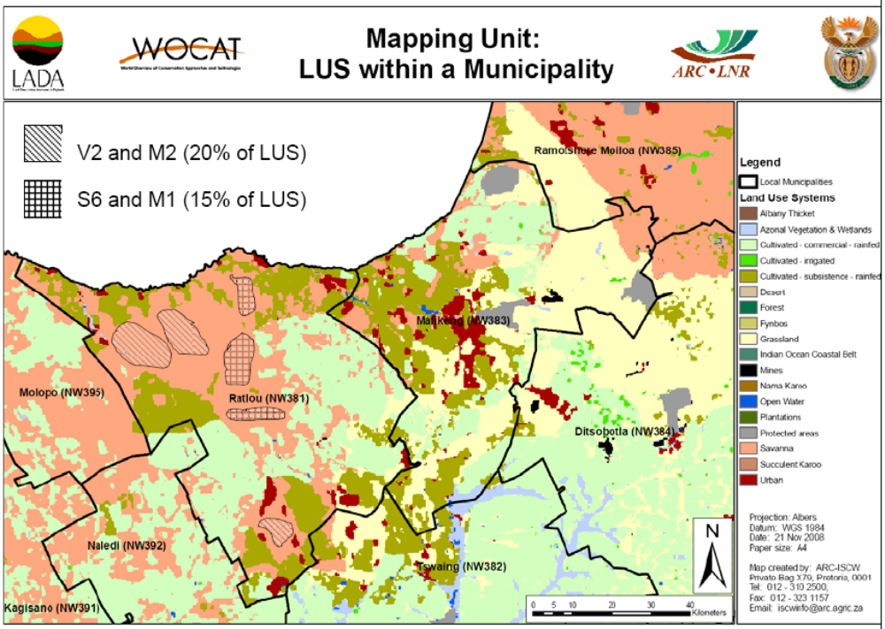
Figure 5: Shows the actual different conservation measures and combinations/ overlaps (shaded areas) within the Savanna LUS in the Ratlou municipality (South Africa). In this case 20 % of the LUS (Savanna) is covered by a combination of measures V2 (reseeding of perennial grasses) and M2 (change of the management from open to controlled grazing) and another 15% by S6 (dams / pans) and M1 (change of land use type) (see Figure 4)

NOTE: The map generated from this information will NOT show the real field situation picture, above but the uniformly coloured LUS unit according to the theme selected.

Step 5: Expert recommendation

For each mapping unit, provide an expert recommendation concerning interventions on how to address degradation (maximum 2). You first need to decide on the best intervention to deal with degradation in that specific mapping unit, either Adaption, Prevention, Mitigation or Rehabilitation. In the Remarks and additional information column provide then more detail about the ‘what’ and ‘how’ of that specific intervention (see example Table 4).

A Adaptation to the problem: the degradation is either too serious to deal with and is accepted as a fact of life, or it is not worthwhile the effort to invest in.

P Prevention implies the use of conservation measures that maintain natural resources and their environmental and productive function on land that may be prone to further degradation, where some has already occurred. The implication is that good land management practice is already in place: it is effectively the antithesis of human-induced land degradation.

M Mitigation: is intervention intended to reduce ongoing degradation. This comes in at a stage when degradation has already begun. The main aim here is to halt further degradation and to start improving resources and their functions. Mitigation impacts tend to be noticeable in the short to medium term: this then provides a strong incentive for further efforts. The word ‘mitigation’ is also sometimes used to describe reducing the impacts of degradation.

R Rehabilitation: is intervention when the land is already degraded to such an extent that the original use is only possible with extreme efforts as land has become practically unproductive. Here longer-term and more costly investments are needed to show any impact.

Table 4: Expert recommendation (Example)

Name: ____X Y_______________________ Country: __South Africa
Mapping Unit Id (LUS + admin. unit): 113 (Savanna + Ratlou municipality)

Expert recommendation (Step 5)
Expert recommendation | Remarks and additional information
P  M | Maintain good soil cover conditions through agroforestry systems  Reduce loss of water through runoff and evaporation by the soil surface through mulching and minimum tillage.

QUESTIONNAIRE

Contributing specialists (Step 1)

If several specialists are involved, write the full data of the main resource person and his/her institution below and add the name of the other person(s) with their institution(s).

Last name / surname: |  | First name(s): ........................................... |  |  | female   male 
Current institution and address:
Name of institution:
Address of institution:
City: |  | Postal Code:
State or District: |  | Country:
Tel: | Fax: |  | E-mail:
Permanent address:
City: |  | Postal Code:
State or District: |  | Country:
Other resource persons involved: |  | Institution: |  | Email

Please confirm that institutions, projects, etc. referred to, have no objections to the use and dissemination of this information by WOCAT – LADA - DESIRE.

Date: ...................................................... Signature:

Thank you in advance!

Please enter the information in the online database, see www.wocat.net/databs.asp or send the completed questionnaire plus any additional materials back to the respective project / programme coordinators: WOCAT: hanspeter.liniger@cde.unibe.ch; LADA: freddy.nachtergaele@fao.org; DESIRE WB1: godert.vanlynden@wur.nl

..
DATA ENTRY TABLE
Please fill out one table for each mapping unit! Make copies of this table as required to fill in information for other mapping units..
Name: ___________________________ Country: ____________________

Mapping Unit Id (LUS + admin. unit): __________________________

Land Use System (Step 2)
a) LUS area trend | b) LUS intensity trend | c) Remarks (e.g. reasons for trend)

Land degradation (Step 3)
a) Type |  |  | b) Extent | c) Degree | d) Rate | e) Direct causes | f) Indirect causes | g) Impact on ecosystem services | h) Remarks
i | ii | iii

Name: ___________________________ Country: ____________________

Mapping Unit ID (LUS + admin. unit): ___________________________

Conservation (Step 4)
a) Name | b) Group | c) Measure |  |  | d) Purpose | e) % of area | f) Degradation addressed |  |  | g) Effectiveness | h) Effect. Trend | i) Impact on ESS | j) Period | k)Ref to QT | l) Remarks

Name: ___________________________ Country: ____________________

Mapping Unit ID (LUS + admin. unit):___________________________

Expert recommendation (Step 5)
Expert recommendation | Remarks and additional information

ANNEX I: Land Use Systems (LUS)

Note: This is an example to illustrate the of LUS. For information concerning the delineation criteria for LUS refer to E1.

 | Land Use System class | Class description
1. | Urban | Essentially compromising all formal build up areas in which people reside on a permanent or near-permanent basis, identifiable by the high density of residential and associated infrastructure, includes cities, towns, villages, and were applicable, the central nucleus of more open rural clusters. Urban areas also include permanent, semi-permanent and non-permanent shack type dwellings, typically established on an informal, ad-hoc basis, on non-serviced sites.
2. | Cultivated Commercial Rainfed | Cultivated areas characterised by large, uniform, well managed field units (i.e. +/- 50 ha) with the aim of supplying both regional, national and export markets. Often highly mechanised. Include fallow and ‘old fields’. It includes all non-timber based plantations such as tea, sisal, citrus, nut crops etc. and planted pastures.
3. | Cultivated Subsistence Rainfed | Characterised by numerous small field units (less than +/- 10 ha) in close proximity to rural population centres. Field units can either be grouped intensive or widely spaced, depending on the extent of the area under cultivation and the proximity to rural dwellings and grazing areas. Commercial Subsistance includes both rainfed and irrigated (i.e. mechanical or gravity-fed), multi-cropping of annuals, for either individual or local (i.e. village) markets. May include fallow and ‘old fields’, and some inter-field grazing areas.
4. | Cultivated Irrigated | Permanent irrigation of most agricultural crops and major irrigation schemes (i.e. areas supplied with water for agricultural purposes by means of boreholes, ditches, rivers, streams or dams. Different forms of irrigation are used on cultivated irrigated areas for example flood, drip or centre pivot irrigation systems amongst various others.
5. | Plantations | All areas of systematically planted, man-managed tree resources, composed of primarily exotic species (including hybrids). Category includes both young and mature plantations that have been established for commercial timber production, seeding trials and woodlots / windbreaks of sufficient size to be identifiable on satellite imagery. Excludes all non-timber based plantations such as tea, sisal, citrus, nut crops etc.
6. | Mines | Active or non-active underground, sub-surface and surface based mining activities. Includes both hardrock or sand quarry extraction sites, and opencast mining sites i.e. coal. Category includes all associated surface infrastructure etc. Primarily non-vegetated, exposed mining (and heavy industry) extraction or waste material are also included in this category.
7. | Protected Areas | National Parks, Provincial Nature Reserves, Bird Sanctuaries, Botanical Gardens, Conservation Areas, DWAF Forest Areas, Mountain Catchment Areas, National Heritage Sites. Excludes private game farms, private nature reserves and state land. They are included in the related natural vegetation biomes.
8. | Open Water | Areas of (generally permanent) open water. The category includes both natural and man-made waterbodies, which are either static or flowing, and fresh brakish and salt-water conditions. This category includes features such as rivers, major reservoirs, farm-level irrigation and stock watering dams, permanent pans, lakes and lagoons.
9. | Succulent Karoo | The succulent Karoo is restricted to the year-round and winter rainfall areas and have the greatest summer aridity. This biome occurs mostly west of the western escarpment through the western belt of the Western Cape and inland towards the Little Karoo. This is the land of many spring flowers. Succulent plant species with thick, fleshy leaves are plentiful here, the diversity of which is unparalleled anywhere else in the world. This, together with many geophytes (plants that survive by means of bulbs, tubers, etc. in times of unfavorable climatic conditions) and annual plants, makes the succulent Karoo unique and of international importance in terms of conservation.
10. | Savannas | Savannas are the wooded grasslands of the tropics and subtropics that account for 46% of the South African landscape. They are second only to tropical forests in terms of their contribution to terrestrial primary production. They are the basis of the livestock industry and the wildlife in these areas is a key tourist drawcard. Savannnas also include valley bushveld, the veld type containing the greatest range of rainfall seasonality in South Africa. Fire is a crucial factor in the ecology of all savannas and is therefore a regular natural feature of this environment.
11. | Fynbos | Fynbos occupies 5,3 % of South Africa, occurring almost exclusively in the south-western and southern parts of the Western Cape Province. Fynbos comprises evergreen heathlands and shrublands in which fine-leafed low shrubs and leafless tufted grasslike plants are typical. Trees are rare and grasses comprise a relatively small part of the biomass. Fire is a very important component in fynbos. Most fynbos is highly flammable due to the common presence of flammable oils. Finely wooded fynbos plants are obligate seeders, which means that the whole plant dies after fire and can only reproduce through seed. This distinguishes fynbos from the other ecosystems where fire is common. Many plant species are dependent for pollination on small mammals or birds such as the Cape sugarbird (Promerops cafer).
12. | Grasslands | The grasslands cover the high central plateau of South Africa, inland areas of Kwazulu-Natal and the mountain areas of the Eastern Cape Province. Grasslands are defined as those areas where grasses dominate the vegetation and where woody plants are absent or rare. They occupy 24,1% of the country’s surface area. Most grassland occurs in high-rainfall areas, where thunderstorms and hail are common in summer and frost is common in winter. The grassland biome is regarded as the third-richest area in terms of plant species diversity, with a total number of 3 788 species. The most noteworthy species with a wide distribution is, Themeda triandra, more commonly referred to as 'rooigras'. In the past the ungulate fauna (hoofed animals) of the Highveld grasslands included vast herds of blesbok (Damaliscus dorcas phillipsi), black wildebeest (Connochaetes gnou) and the springbok (Antidorcas marsupialis). A surprisingly rich variety of birds are found in the grasslands, including the blue crane (Anthropoides paradiseus), black korhaan (Eupodotis afra) and helmeted guineafowl (Numida meleagris).
13. | Forests | The forests of South Africa include the indigenous evergreen and semi-deciduous closed forests of the coastal lowlands and escarpment slopes and cover only about 0.25% of the land area.With a few exceptions such as the forests of the Knysna area and the KwaZulu-Natal coastal dune systems, forests are small, usually occupying less than 1 000 ha. These forests amount to little more than patches scattered through the higher rainfall areas. The total area of forests in South Africa is probably less than 2 000 km². The forest structure results in reduced light levels in the area beneath the canopy where species such as tree ferns are common. Typical mammals include the bushbuck (Tragelaphus scriptus), bush pig (Potamochoerus porcus) and blue duiker (Philantomba monticola). Birds found in forests include the Knysna lourie (Tauraco corythaix) and rameron pigeon (Columba arquatrix). Despite the small land surface area that they occupy, forests have relatively high species richness. Only fynbos exceeds the species richness found in forests.
14. | Nama Karoo | The Nama-Karoo covers most of the vast central plateau region of the Western and Northern Cape Provinces. The area forms an ecotone or transition between the Cape flora to the south, and the tropical savanna in the north. Many of the plant species of the Nama-Karoo also occur in the savanna, grassland, succulent Karoo and fynbos biomes.Species that occur in the Nama-Karoo include the sweet-thorn (Acacia karroo), stone plant (Lithops ruschiorum) and blue Karoo daisy (Felicia australis). The former vast migratory herds of springbok (Antidorcas marsupialis) have been replaced by domestic stock, particularly sheep and goats. A rich variety of rodents and reptiles, also occurs in the Nama-Karoo. The few, endemic or near-endemic bird species include the Sclaters lark (Spizocorys sclateri). Sheep-farming is the main agricultural activity in this region.
15. | Marine and coastal ecosystems | The South African coastline covers a distance of over 3 000 km, more than 80% of which consists of sandy beaches and sand dunes. Other ecosystems include rocky shores, coral reefs, kelp beds and the open sea. Two hundred and seventy of the world’s 325 fish families occur in South African waters. The east coast waters are characterised by the warm waters of the southward flowing Agulhas Current, while those of the west coast are characterised by the upwelling of cold, nutrient-rich waters of the Benguela Current. Along the southwest and south coast, there is an extensive mixing of water masses. The currents influence the composition of the animal and plant communities along this coastline.
16. | Wetland (Azonal vegetation) | The term "wetlands" groups together a wide range of inland and coastal habitats – from mountain sponges and midland marshes to swamp forests and estuaries – linked by rivers and streams. These wetlands share common and important functions in river catchments by providing a regular water supply, by filtering the water naturally, by reducing the effects of floods and droughts, and by providing a vital wildlife habitat and superb recreational areas for people. Most wetlands are characterised by a high water table, water-carrying soil and hydrophytes (water-loving plants), but in semi-arid Southern Africa there are numerous pans that support few if any hydrophytes and that may contain shallow water only once in five or more years.

References for South African land use system class descriptions:

CSIR & ARC (2005). National Land-Cover Database 2000. Council for Scientific and Industrial Research and the Agricultural Research Council.

Mucina, L & Rutherford, M.C. (eds) (2006). The vegetation of South Africa, Lesotho and Swaziland. Strelitzia 19. South African National Biodiversity Institute, Pretoria.

ANNEX II: Conservation measures (as defined in QM E17-18)

Main types and subtypes
A: Agronomic / soil management
A1: Vegetation / soil cover
- better soil cover by vegetation (selection of species, higher plant density)
- early planting (cropland)
- relay cropping
- mixed cropping / intercropping
- contour planting / strip cropping
- cover cropping
- retaining more vegetation cover (removing less vegetation cover)
- mulching (actively adding vegetative / non-vegetative material or leaving it on the surface)
- temporary trash lines (and in A2 as “mobile compost strips”)
- others
A2: Organic matter / soil fertility
- legume inter-planting (crop and grazing land; induced fertility)
- green manure (cropland)
- applying manure / compost / residues (organic fertilisers), including “mobile compost strips” (trash lines)
- applying mineral fertilisers (inorganic fertilisers)
- applying soil conditioners (eg use of lime or gypsum)
- rotations / fallows (associated with M)
- others
A3: Soil surface treatment
- conservation tillage: zero tillage, minimum tillage and other tillage with reduced disturbance of the top soil
- contour tillage
- contour ridging (crop and grazing land), done annually or in rotational sequence
- breaking compacted top soil: ripping, hoeing, ploughing, harrowing
- pits, redone annually or in rotational sequence
- others
A4: Subsurface treatment
- breaking compacted subsoil (hard pans): deep ripping, “subsoiling”, …
- deep tillage / double digging
- others
A5: Others

V: Vegetative
V1: Tree and shrub cover
- dispersed (in annual crops or grazing land): eg Faidherbia, Grevillea Sesbania
- aligned (in annual crops or grazing land): eg live fences, hedges, barrier hedgerows, alley cropping
Subcategories:
- on contour
- graded
- along boundary
- linear
- against wind
- in blocks
Subcategories:
- woodlots
- perennial crops (tea, sugar cane, coffee, banana)
- perennial fodder and browse species
Further subcategories for dispersed, aligned and in blocks:
- natural reseeding
- reseeding
- planting
V2: Grasses and perennial herbaceous plants
- dispersed
- aligned (grass strips)
Subcategories:
- on contour
- graded
- along boundary
- linear
- against wind
- in blocks
Further subcategories for dispersed, aligned and in blocks:
- natural reseeding
- reseeding
- planting
V3: Clearing of vegetation
: V4: Others
S: Structural:
Structures constructed with soil or soil enforced with other materials (S1-S7) or entirely from other materials such as stone, wood, cement, others (S-8)
S1: Bench terraces (<6%)
- level (incl. rice paddies)
- forward sloping /outward sloping
- backward sloping / back-sloping / reverse
S2: Forward sloping terraces (>6%)
S3: Bunds / banks
- level
- tied
- non-tied
- graded
- tied
- non-tied
- semi-circular
- v-shaped
- trapezoidal
- others
S4: Graded ditches / waterways (to drain and convey water)
- cut-off drains
- waterways
S5: Level ditches / pits
- infiltration, retention
- sediment / sand traps
S6: Dams / pans: store or harvest water for irrigation, human or animal consumption
S7: Reshaping surface (reducing slope, …) / top soil retention (eg in mining storing top soil and re-spreading (*)
S8: Walls / barriers / palisades, (constructed from wood, stone concrete, others, not combined with earth)
S9: Others
M: Management:
M1: Change of land use type:
- enclosure / resting
- protection
- change from crop to grazing land, from forest to agroforestry, from grazing land to cropland, etc.
M2: Change of management / intensity level:
- from grazing to cutting (for stall feeding)
- farm enterprise selection: degree of mechanisation, inputs, commercialisation
- from mono-cropping to rotational cropping
- from continuous cropping to managed fallow
- from “laissez-faire” (unmanaged) to managed, from random (open access) to controlled access (grazing land forest land eg access to firewood), from herding to fencing
- adjusting stocking rates
- staged use to minimise exposure (eg staged excavation)
M3: Layout according to natural and human environment:
- exclusion of natural waterways and hazardous areas
- separation of grazing types
- distribution of water points, salt-licks, livestock pens, dips (grazing land)
M4: Major change in timing of activities:
- land preparation
- planting
- cutting of vegetation
M5: Control / change of species composition (not annually or in a rotational sequence: if annually or in a rotational sequence as done eg on cropland -> A1)
- reduction of invasive species
- selective clearing
- encouragement of desired species
- controlled burning / residue burning
M6: Waste management: Any measures which includes recycling, re-use or reduce: includes both artificial and natural methods for waste management
M7: Others

Combinations:
Often there are combinations: list them according to importance, eg A3 V2

ANNEX III : Drivers-Pressure-State-Impact-Response (DPSIR) Diagramme

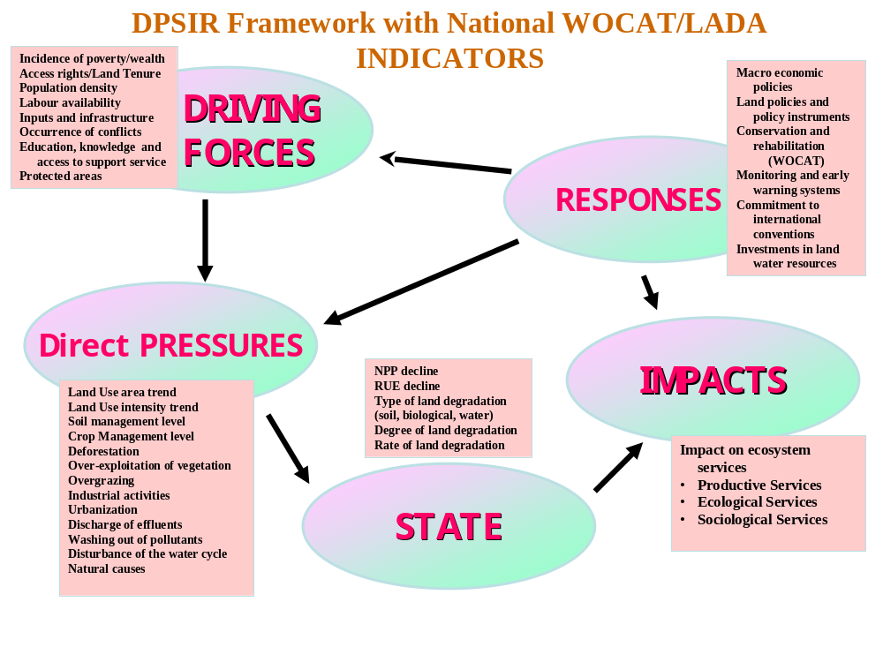

Could also be a watershed/ basin
Refers to indicators within DPSIR framework for degradation and conservation in Annex 3.
Refers to indicators of DPSIR framework of degradation and conservation in Annex 3.
Refers to indicators of DPSIR framework of degradation and conservation in Annex 3.
Refers to indicators of DPSIR framework of degradation and conservation in Annex 3.
Refers to indicators of DPSIR framework of degradation and conservation in Annex 3.

